5. What Your Results Suggest

2 Examples Based on Scores (referencing thresholds) + Domains + Relevant Questions

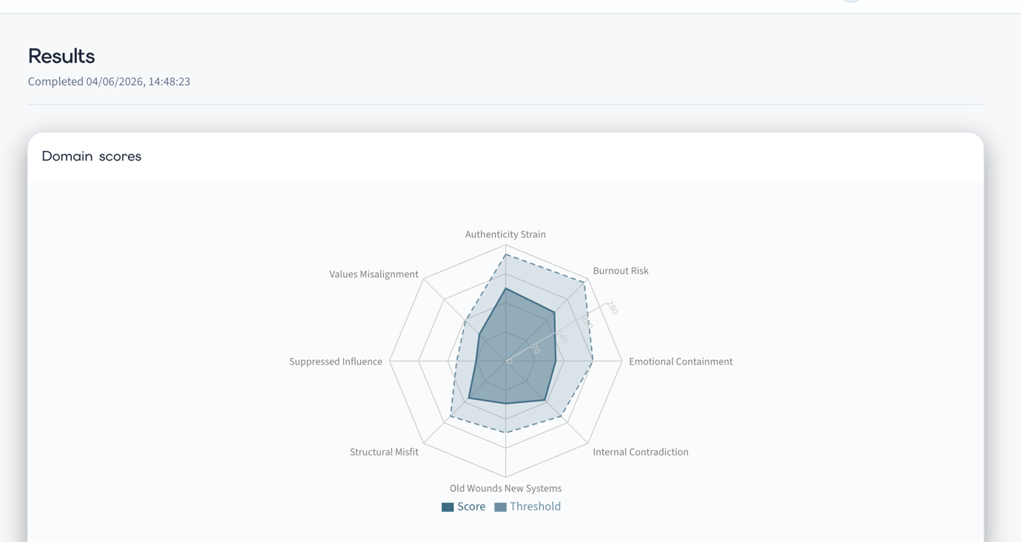

Understanding the Pattern
The pattern identified in your results appears to be driven less by capability or commitment, and more by the relationship between your natural way of operating and the environment in which you are working. Responses associated with this profile often reflect a perception that success requires a degree of adaptation, conformity, or self-management that extends beyond the normal demands of a role. While such adaptation can be effective in the short term, it may gradually create distance between how a person naturally thinks, communicates, or works and how they feel expected to present themselves professionally.
At the same time, the elevated burnout profile suggests that the cost of this adaptation may not be purely psychological. The strongest contributors to burnout within this assessment are linked not only to workload, but also to energy, recovery, support, and environmental fit. When individuals feel required to continually adjust themselves to meet cultural or organisational expectations, effort can become increasingly concentrated on maintaining alignment with the system rather than on the work itself. Over time, this can create a sense that professional effectiveness is being achieved at a disproportionate personal cost.
Taken together, this profile suggests that the central challenge may not be one of performance, motivation, or competence. Rather, it points toward a system in which the ongoing effort required to fit, adapt, or sustain expectations may be consuming resources that would otherwise be available for engagement, creativity, resilience, and long-term growth.

NB
Looking at the weighting structure, a person does not arrive at high Authenticity Strain simply because they answered a few questions about authenticity. The construct is being built from a fairly specific constellation of experiences:

High-weight contributors to Authenticity Strain include:
- Feeling under-represented in the culture
- Unspoken cultural dynamics
- Identity affecting perceptions of competence
- Suppressing aspects of oneself to gain acceptance
- Lack of opportunities for diverse people to thrive
- Poor fit between personality and company culture
- A culture of conformity
- Inability to express oneself authentically
- Success being rewarded in ways that conflict with personal values
- A mismatch between organisational pace and natural rhythm
Similarly, Burnout Risk is not simply "working too hard."
High-weight contributors include:
- Feeling tense and overwhelmed
- Low energy and resilience
- Lack of organisational support for wellbeing
- Poor accommodation of natural energy fluctuations
- Poor fit between personality and culture
- A mismatch between organisational pace and natural rhythm
- Lack of recovery through family and support systems
- Financial pressures influencing professional behaviour
That means the report can move beyond: "You scored high on Authenticity Strain."
and begin explaining: "The particular way in which you arrived at this score."

Example 2
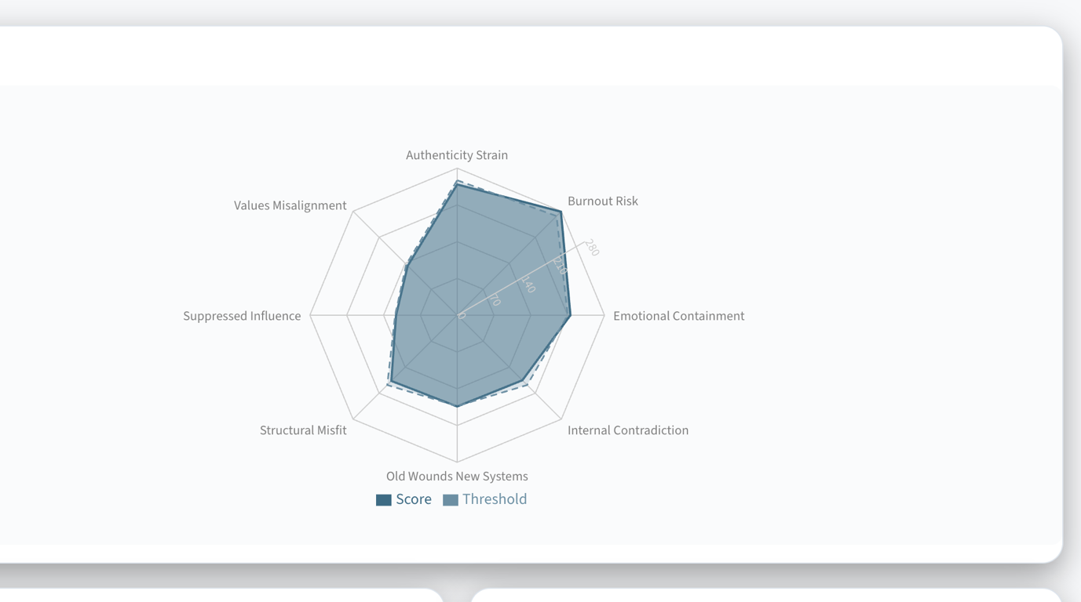

Understanding the Pattern
The pattern identified in your results suggests that the primary source of strain is likely to be environmental rather than personal. While there is little evidence of significant internal conflict, unresolved past influences, or uncertainty about personal values, there are indications that aspects of your current environment may require a level of adaptation that feels increasingly effortful to sustain. In these circumstances, the challenge is often not knowing what matters or what needs to be done, but rather the ongoing effort required to fit, perform, or operate effectively within the existing system.
The combination of elevated authenticity strain and burnout risk suggests that energy may be consumed not only by the demands of the work itself, but also by the process of continually managing how one presents, communicates, or functions within the environment. This can create a situation where professional performance remains outwardly intact, while the personal cost of maintaining that performance gradually increases. Because this pattern develops through sustained adaptation rather than acute stress, it is often experienced as exhaustion, frustration, or disengagement that accumulates slowly over time.
Taken together, these results suggest that the central issue may be one of fit rather than capability. The assessment does not indicate a lack of motivation, commitment, or resilience. Instead, it points toward a situation in which the effort required to remain aligned with the environment may be consuming resources that would otherwise be available for creativity, growth, recovery, and long-term engagement.

Suppose:
Authenticity Strain is elevated.
The engine identifies:
{
"highest_domain": "Authenticity Strain",
"major_contributors": [
{
"subdomain": "Culture",
"strength": "High"
},
{
"subdomain": "Hierarchy",
"strength": "High"
}
],
"key_items": [
"I avoid expressing disagreement openly",
"I adjust my behaviour depending on who is present",
"I feel pressure to present myself in a particular way"
]
}
Now the LLM can write:
The pattern identified here appears to be driven primarily by environmental rather than personal factors. Responses suggest a tendency to adapt behaviour in response to social, cultural, or hierarchical expectations, particularly in situations where disagreement, visibility, or self-expression may carry perceived consequences. Over time, this can create a gap between how a person naturally operates and how they feel required to operate within the system.
That is much more compelling.

My Recommendation
For Section 5, the LLM should receive:

1. The elevated domains
{
"domain": "Authenticity Strain",
"level": "High"
}

2. The major contributing subdomains
[
"Culture",
"Hierarchy",
"Relationships"
]

3. The top 3–5 contributing questions
Not the answers.
The themes.
For example:
[
"Difficulty expressing disagreement",
"Need to adapt communication style",
"Concern about perceptions"
]

4. Relevant interaction themes
[
"Adaptation is increasing energy expenditure"
]

What the LLM Does NOT Need
I would not give it:
{
"question_84": 4,
"question_85": 2,
"question_86": 5
}
The raw scores are not meaningful to the language model.
The engine should convert those into:
{
"theme": "Difficulty expressing disagreement"
}
before the LLM ever sees them.

A Useful Architecture
I would build an intermediate layer.
Question Scores
↓
Weightings
↓
Domains
↓
Subdomains
↓
Theme Extraction Layer
↓
LLM
The Theme Extraction Layer becomes extremely important.

For example:

Burnout Risk
The engine might produce:
{
"domain": "Burnout Risk",
"themes": [
"Sustained performance pressure",
"Difficulty disengaging from work",
"Limited opportunity for recovery"
]
}
The LLM can then explain:
The elevated burnout score appears to be driven less by acute stress and more by the cumulative effect of sustained demand. Responses suggest that periods of pressure may be prolonged, while opportunities for psychological or practical recovery remain limited. In these circumstances, fatigue often emerges gradually and can be difficult to recognise until it begins to affect motivation, engagement, or resilience.
That feels personalised because it is grounded in the person's actual response pattern.

